Submarine Cable Analysis for US Marine Renewable Energy Development

Benjamin D. Best 1

Levi F. Kilcher 2

2017-10-09  
1: EcoQuants, Santa Barbara, CA  
2: National Renewable Energy Lab, Golden, CO

Table of Contents

Executive Summary 2

Background 4

Methods 5

Study Area, Submarine Cables, Depth and Energy Data 5

Submarine Cable Avoidance Zones 8

Depth-Varying Cable Buffer 8

Reproducible Code 8

Results 9

Cable Buffer 9

Overlap of Cable Buffer with Renewable Energy 10

Tidal 13

Wave 13

Wind 14

Discussion 14

Conclusion 15

(APPENDIX) Appendix 17

Maps by US Territory of Cable Buffer and Renewable Energy 17

Tide 17

Alaska 17

East 18

Gulf of Mexico 19

Puerto Rico 20

US Virgin Islands 21

West 22

Wave 23

Alaska 23

East 24

Gulf of Mexico 25

Hawaii 26

Puerto Rico 27

US Virgin Islands 28

West 29

Wind 30

East 30

Gulf of Mexico 31

Hawaii 32

West 33

References 33

# Executive Summary

Marine energy (offshore wind, tidal, wave) have the potential to help diversify the U.S. renewable energy porfolio, which is important to reducing reliance on foreign non-renewable energy sources, powering the U.S. economy in the 21st century, creating jobs, and to reducing greenhouse gas emissions that contribute to climate change. The first U.S. commercial marine energy facility went into production in December of 2016: the Block Island (Rhode Island) offshore wind farm. As implementation costs for these technologies continue to drop and increasingly ambitious targets for renewable energy are set, marine renewable energy planning and development will need to effectively evaluate competing ocean uses. Marine renewable energy may be complementary to other large scale renewables by offering consistent energy in high demand times during morning and evening hours when solar is less available and in proximity to coastal areas where populations tend to concentrate (Gilman et al. 2016; Lehmann et al. 2017).

Operation and maintenance of submarine cables may conflict with marine renewable energy development. The submarine cable industry handles 95% of inter-continental internet, data and voice traffic (Communications Security, Reliability and Interoperability Council IV 2014), and is thus vital to the US and global economy. Repair and maintenance of cables traditionally involves grappling the cable and floating it to the surface, so allowance for drift of the repairing vessel and laying down of the additional splice of cable is depedent on bottom depth. Although submarine cable locations are publicly accessible through electronic navigation charts, a clear understanding of the areas where cable paths compete with promising marine energy sites does not yet exist.

We applied industry-advised safety buffers (‘setback’ distances) to map the areas where the cable industry is a stakeholder. This was done using two setback widths: a twice-depth (‘2z’) buffer for new "facilities", and a three-times depth (‘3z’) for new "cables" to prevent overlap of bights for newly spliced cable material. Both of these buffers have a minimum 500 m buffer on either side. Of the original 230,835 km of cable in the "NOAA Charted Submarine cables in the United States as of December 2012" dataset (Figure 2), 97,321 km fell within the 200 nm of the US exclusive economic zone (EEZ), which was analyzed across 12 territories that overlapped with the cables (Figure 2). The cable buffer area ranged from 29.35% (242,031 km2 [3z] of 824,679 km2 total) along the West owing to many cables present and the steep continental shelf, to virtually nill 0.39% (6,133 km2 [2z] of 1,553,288 km2 total) in the Gulf of Mexico (Table 2).

Overlap of cable buffers with marine renewable energy was assessed for tidal (Haas et al. 2011), wave (P. T. Jacobson et al. 2011) and wind (Schwartz et al. 2010) energy based on energy resource characterizations available through the National Renewable Energy Lab (NREL) Wind Prospector[1] or MHK Atlas[2]. Assessment of overlap with the advised separation schemes and energy resource was limited to maximum depths based on current assessment of technology limitations : < 100 m for tidal (Haas et al. 2011), < 200 m for wave (P. T. Jacobson et al. 2011), < 1,000 m for wind (Musial et al. 2016). The lowest energy classes were also dropped from the assessment (tidal: > 500 , wave: > 10 , wind: > 7 ) viable for energy development.

Total area of viable tidal resource (1,671 ) is orders of magnitude less than wave (378,908 ) or wind (462,613 ) owing to requirements for channelized bathymetry (Table 2). Nationally, tidal energy has up to 3.8% overlap, wave 0.9% and wind 4% (Table 2), so conflict between viable marine renewable energy resource and existing submarine cables is generally minimal. However a small fraction of viable resource areas in high energy areas is notable. For instance, for the small area (207 ) of highest wind speeds (11-12 m/s) occurring only in Hawaii overlap is up to 37.9% (Table 6). The lowest tidal energy class (500 - 1,000 ) in the West region (11 ), largely around Puget Sound, has 31.5% overlap (Table 4). The report provides a detailed breakdown of overlap with energy resource by depth, energy class and territory.

Energy resources are unevenly distributed across territories. Tidal power (Table 4) is most abundant in Alaska (691 at 500 - 1,000 ), the East (390 at 500 - 1,000 ) and the West (46 at 500 - 1,000 ), which is where overlap with cable buffers is most significant (23.4 - 31.5%) such as around Port Townsend, WA (Figure 8). Wave energy (Table 5) is most abundant in the Pacific territories having the most exposure to storm activity across the largest ocean. Alaska has the most abundant energy across all viable energy classes. Wind speeds (Table 6) in excess of 9 are not found in the Gulf of Mexico and limited to the offshore New England area of the East (Figure 16), offshore areas of California and Oregon in the West (Figure 16) and dispersed locations in Hawaii (Figure 16).

The proposed avoidance areas for submarine cables should be deemed advisory. Overlap with the new facility (3z) or cable (2z) buffers around existing submarine cables does not nullify the possibility of renewable energy development there. Rather, it should alert the developer to negotiate reasonable terms with the cable operator via contacting the cable industry, such as the North American Submarine Cable Association[3] or the International Cable Protection Committee[4]. These avoidance zones are advised according to traditional methods of submarine cable repair involving grappling of the submarine cable and buoying to the surface for repair, hence allowance for sway of boat as a function of depth. In future, use of more sophisticated remotely operated vehicles may narrow safe operating distances. These avoidance areas are limited to the most recent submarine cable data. Any planning for marine renewable energy should consult the latest electronic navigation charts and contact the cable industry for confirmation.

# Background

Demand for abundant and diverse resources in the oceans is growing, necessitating marine spatial planning. To inform development of Marine Hydrokinetic (MHK) and Offshore Wind (OSW) resources, the Department of Energy (DOE) has asked NREL to identify the competing uses areas between promising MHK/OSW sites and submarine power and telecommunications cables. The first step in this work is to identify and quantify the overlap between the MHK/OSW resource availability and existing cable routes.

The analysis is done in terms of resource area because the task of quantifying actual impacts on available resource is a non-trivial undertaking that involves subjective decisions of identifying resource opportunities. Quantifying overlap in-terms of resource area—on the other hand—is significantly more straight forward, and useful to marine spatial planners.

The submarine cable industry handles 95% of inter-continental internet, data and voice traffic (Communications Security, Reliability and Interoperability Council IV 2014), and is thus vital to the US and global economy. Repair and maintenance of cables traditionally involves grappling the cable and floating it to the surface, so allowance for drift of the repairing vessel and laying down of the additional splice of cable is depedent on bottom depth. Although submarine cable locations are publicly accessible through electronic navigation charts, a clear understanding of the areas where cable paths compete with promising marine energy sites does not yet exist.

The submarine cable industry handles 95% of inter-continental internet, data and voice traffic (Communications Security, Reliability and Interoperability Council IV 2014), and is thus vital to the US and global economy. Repair and maintenance of cables traditionally involves grappling the cable and floating it to the surface, so allowance for drift of the repairing vessel and laying down of the additional splice of cable is depedent on bottom depth (Figure 1).

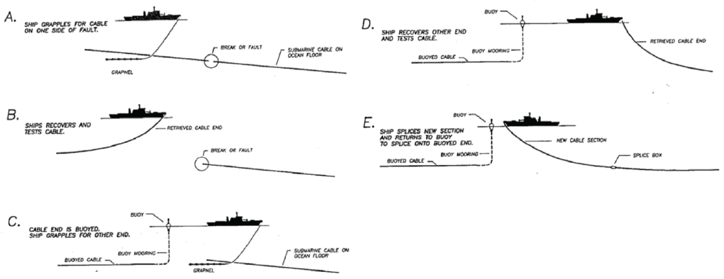

Figure 1 Ship operations for submarine cable repair. The ship runs a grapnel along the seafloor to catch the cable before the break, recovers and buoys one end of the cable, grapples and recovers the other, and splices a new section of repaired cable before laying it back onto the seafloor. Source: Tyco Electronics Subsea Communications, LLC

Although submarine cable locations are publicly accessible through several publicly available datasets and electronic navigation charts, a clear understanding of the areas where cable paths compete with promising marine energy sites does not yet exist. By applying industry advised setback distances from existing cables, we seek to minimize conflict between this vital industry and the growing blue economy of marine renewable energy.

# Methods

## Study Area, Submarine Cables, Depth and Energy Data

The study area consisted of the US waters (Flanders Marine Institute 2016), i.e. the 200 nm extent deemed the exclusive economic zone (EEZ). We used the most comprehensive publicly available submarine cable dataset "NOAA Charted Submarine cables in the United States as of December 2012" available through MarineCadastre.gov.[5] The contiguous US is further divided to yield the following anlytical territories: Alaska, Hawaii, West coast, East coast, Gulf of Mexico, Puerto Rico, US Virgin Islands and Pacific Islands (Guam, Johnston Atoll, N. Mariana Islands, Palmyra Atoll and Wake Island). The Gulf of Mexico description based on the International Hydrographic Organization (IHO) Sea Areas (VLIZ 2017) was used to seperate the original Atlantic US territory into East coast and Gulf of Mexico. To accomodate territories overlapping the international dateline (Hawaii and Alaska), all input and output products were shifted from [-180,180] to [0,360] longitude space. The original 12 territories and cable dataset are depicted on a map (Figure 2) before extraction of cables within the area of the 7 analyzed territories (after lumping the Pacific Islands) within the US EEZ (Table 1).

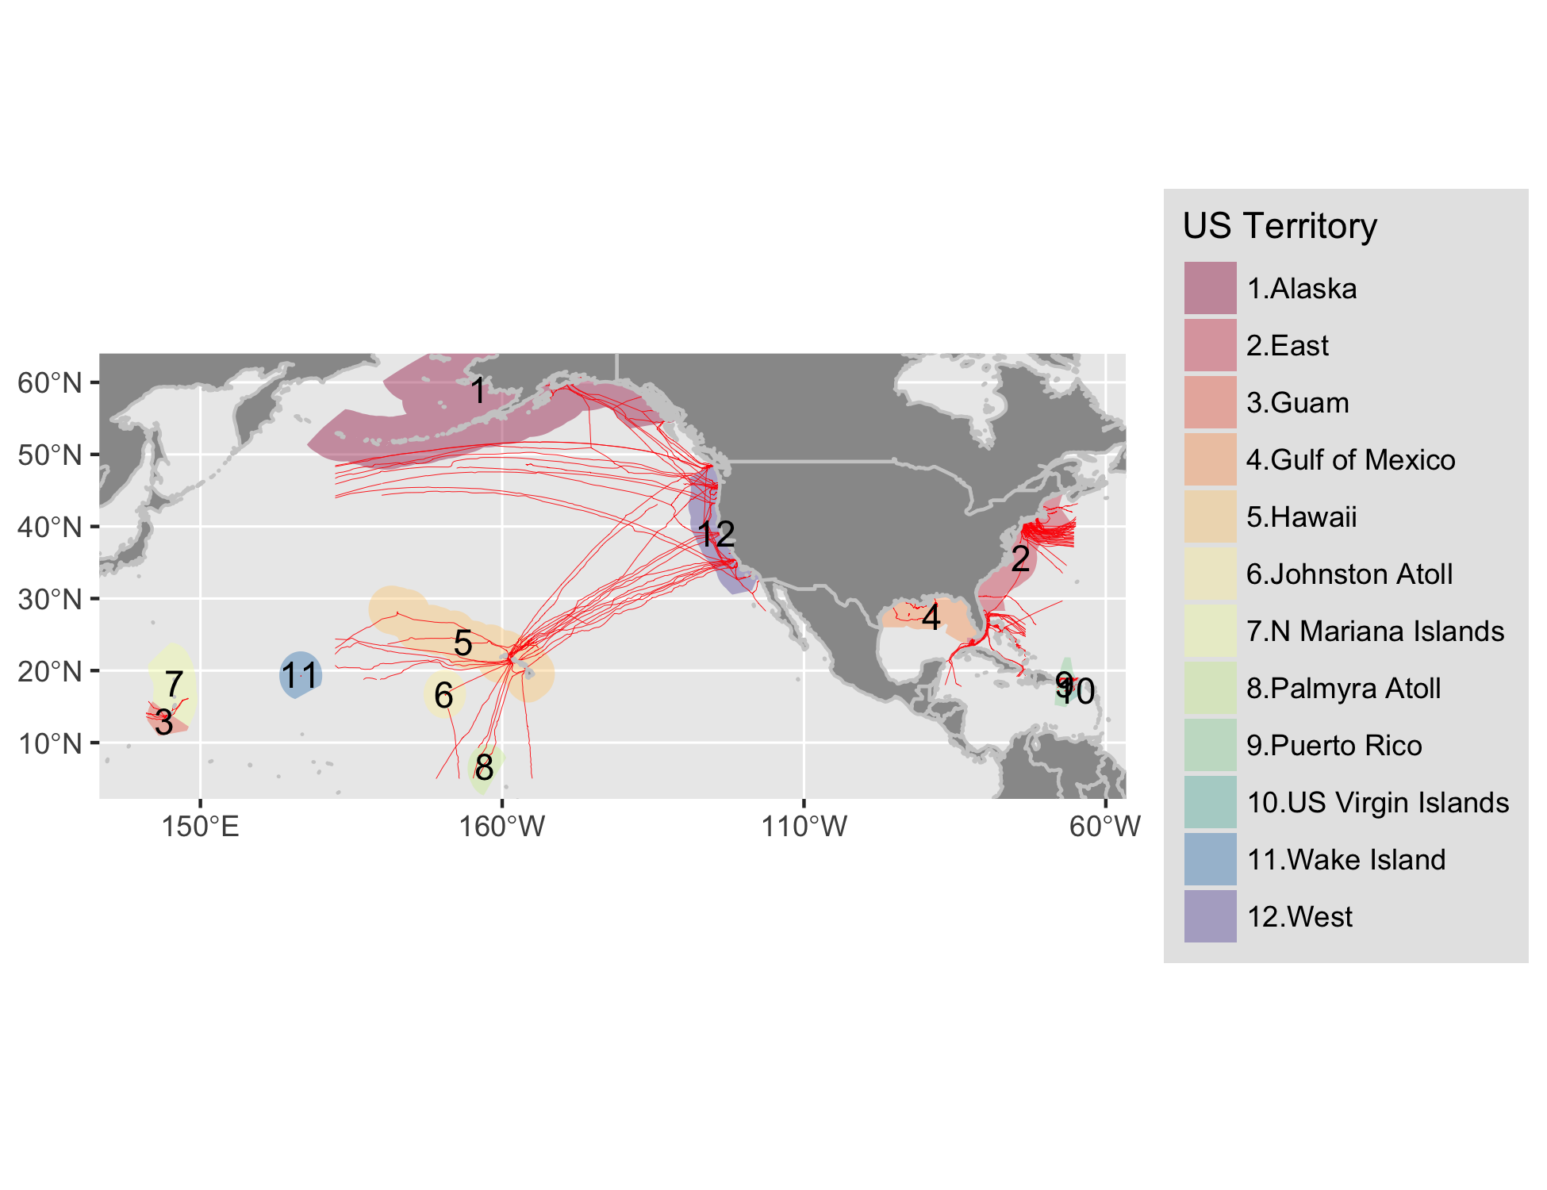

Figure 2 Map of NOAA charted submarine cables (red lines) as of December 2012 within the exclusive economic zone (EEZ; 200 nm) overlapping with United States territories. Note throughout the rest of the report that some territories are grouped: Pacific Island territories (Guam, Johnston Atoll, N. Mariana Islands, Palmyra Atoll, Wake Island) and Atlantic Island territories (Puerto Rico, US Virgin Islands).

Bathymetric depth, using the [GEBCO 30 arc-second grid](http://www.gebco.net/data_and_products/gridded_bathymetry_data/gebco_30_second_grid/)[6] (Weatherall et al. 2015), was used to extract the depth of the cables and energy resource characterizations.

The marine renewable energy datasets from NREL are accessible online via NREL's Wind Prospector[7] and MHK Atlas[8]. Tidal data were modeled using the Regional Ocean Modeling System and calibrated with available measurements of tidal current speed and water level surface in terms of watts per square meter (W/m2) (Haas et al. 2011). Wave data is based on a 51-month Wavewatch III hindcast database developed by the National Oceanographic and Atmospheric Administration’s (NOAA’s) National Centers for Environmental Prediction for estimation of wave power density in terms of kilowatts per meter (kW/m) (P. T. Jacobson et al. 2011). Wind data is for average offshore wind speed in meters per second (m/s) at a 90 m hub height[9] (Schwartz et al. 2010).

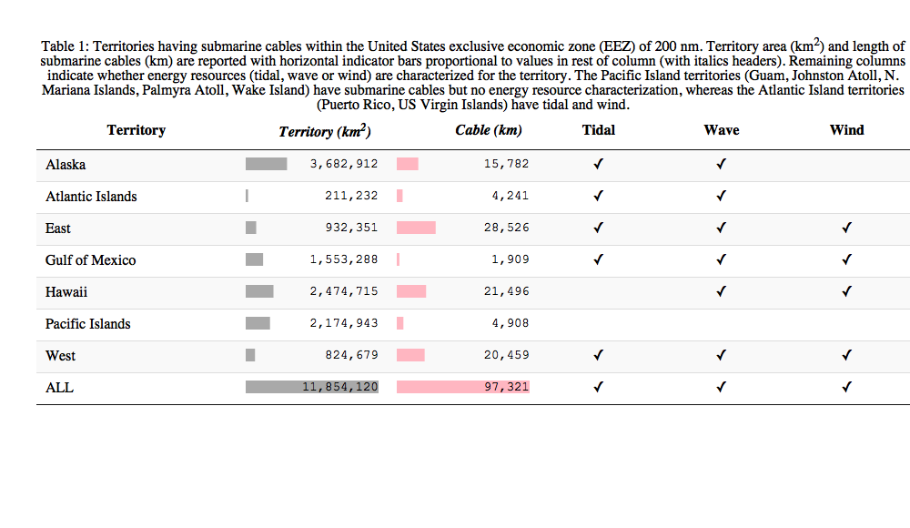

## Submarine Cable Avoidance Zones

The International Cable Protection Committee (ICPC)[10] of the North American Submarine Cable Association (NASCA)[11] outlined recommended setback distances (Communications Security, Reliability and Interoperability Council IV 2014, 2016) for siting new offshore renewable wind energy facilities and routing new cables.

* **New Facilities**: the maximum of 500 m or twice the bottom depth (2z), per ICPC Recommendation 13 No. 2 (Communications Security, Reliability and Interoperability Council IV 2014). For depths <= 250 m, a 500 m buffer from the cables applies and for depths > 250 m, 2 * depth is to be used. This product is referred to as the "facilities (2z)" product throughout this report.
* **New Cables**: the maximum of 500 m or thrice the bottom depth (3z), per ICPC Recommendation 2 No. 10 (Communications Security, Reliability and Interoperability Council IV 2014). So for depths <= 250 m, a 500 m buffer from the cables applies and for depths > 250 m, 3 * depth is to be used. This product is referred to as the "cables (3z)" product throughout this report.

## Depth-Varying Cable Buffer

A depth-varying buffer from existing submarine cables for new facilities (2z) and cables (3z) was calculated by intersecting depth with cables and buffering the cable segment by the depth multiplier. Depth from the GEBCO grid was reclassed into 100 m increments starting with 250 m to apply a 500 m minimum for the 2z and 3z products, and converted to polygons for intersecting with the cable linear features. A custom Albers Equal Area Conic projection based on 1/6th the extent[12] of each territory was individually applied to minimize spatial distortion when buffering.

## Reproducible Code

In the spirit of reproducible research (Lowndes et al. 2017; Madeyski and Kitchenham 2015), all analytical code to generate outputs, including this data driven report, are available in a publicly accessible online repository: <http://github.com/ecoquants/nrel-cables>. Here are particularly noteworthy files:

* data/
  + [lns_d1x.geojson](https://github.com/ecoquants/nrel-cables/blob/master/data/lns_d1x.geojson): lines of submarine cables segmented at 100 m increments with depth value for buffering, ie minimum 500 m and depth (z) for multiplying by 2 (2z) or 3 (3z).
  + [buf_2xdepth_incr100m.geojson](https://github.com/ecoquants/nrel-cables/blob/master/data/buf_2xdepth_incr100m.geojson): polygons for siting new facilities buffered from existing submarine cables at twice the depth (2z), mimimum 500 m.
  + [buf_3xdepth_incr100m.geojson](https://github.com/ecoquants/nrel-cables/blob/master/data/buf_3xdepth_incr100m.geojson): polygons for siting new cables buffered from existing submarine cables at three times the depth (3z), mimimum 500 m.
* docs/
  + [packages_vars.R](https://github.com/ecoquants/nrel-cables/blob/master/docs/packages_vars.R): R code with variables and packages used across analysis (create_cable-buffer.R, extract_cable-energy.R) and reporting (report.Rmd)
  + [create_cable-buffer.R](https://github.com/ecoquants/nrel-cables/blob/master/docs/create_cable-buffer.R): R code to generate cable buffers at 100 m depth increments.
  + [extract_cable-energy.R](https://github.com/ecoquants/nrel-cables/blob/master/docs/extract_cable-energy.R): R code to extract renewable energy for cabled territories.
  + [report.Rmd](https://github.com/ecoquants/nrel-cables/blob/master/docs/report.Rmd): R markdown document for reproducible, data-driven generation of various report output file formats (report.pdf, report.docx, report.html)

# Results

## Cable Buffer

Of the original 230,835 km of cable in the "NOAA Charted Submarine cables in the United States as of December 2012" dataset (Figure 2), 97,321 km fell within the 200 nm of the US exclusive economic zone (EEZ), which was analyzed across 12 territories that overlapped with the cables (Figure 2). The cable buffer area ranged from 29.35% (242,031 km2 [3z] of 824,679 km2 total) in the West owing to many cables present and the steep continental shelf, to virtually nill 0.39% (6,133 km2 [2z] of 1,553,288 km2 total) in Gulf of Mexico (Table 2).

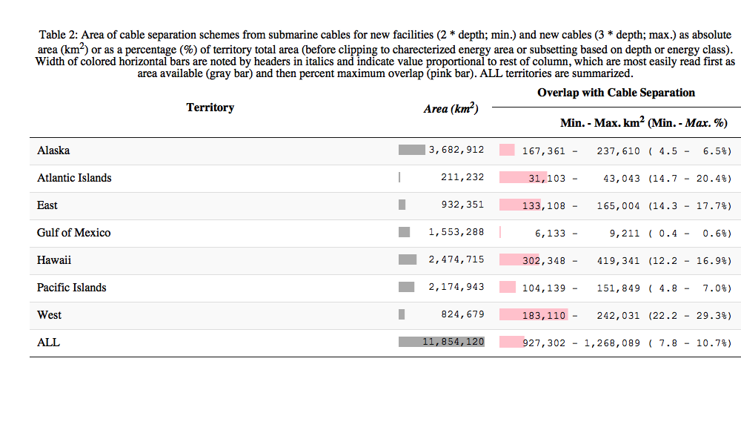

## Overlap of Cable Buffer with Renewable Energy

Overlap of cable buffers with marine renewable energy was assessed for tidal (Haas et al. 2011), wave (P. T. Jacobson et al. 2011) and wind (Schwartz et al. 2010) energy based on energy resource characterizations available through the National Renewable Energy Lab (NREL) Wind Prospector[13] or MHK Atlas[14]. Assessment of overlap with the advised separation schemes and energy resource was limited to maximum depths based on current assessment of technology limitations: < 100 m for tidal (Haas et al. 2011), < 200 m for wave (P. T. Jacobson et al. 2011), < 1,000 m for wind (Musial et al. 2016). The lowest energy classes were also dropped from the assessment (tidal: > 500 , wave: > 10 , wind: > 7 ) viable for energy development.

Total area of viable tidal resource (1,671 ) is orders of magnitude less than wave (378,908 ) or wind (462,613 ) owing to requirements for channelized bathymetry (Table 3). Nationally, tidal energy has up to 3.8% overlap, wave 0.9% and wind 4% (Table 3), so conflict between viable marine renewable energy resource and existing submarine cables is generally minimal. However a small fraction of viable resource areas in high energy areas is notable. For instance, for the small area (207 ) of highest wind speeds (11-12 m/s) occurring only in Hawaii overlap is up to 37.9% (Table 6). The lowest tidal energy class (500 - 1,000 ) in the West region (11 ), largely around Puget Sound, has 31.5% overlap (Table 4).

Viable tidal resource (Table 3) have up to 4.7% overlap for the lowest energy class (500 - 1,000 ) with only 2.3% and 0.9% overlap at higher power classes 1,000 - 1,500 and > 1,500 respectively. Wave energy at either depth bin of 0 - 100 or 100 - 200 m is very low with at most 2% overlap for the lower energy class (10-20 ) at depths 100 - 200 m. The most abundant viable wind in shallow depth (0 - 100 m) and lower energy (7 - 8 and 8 - 9 ) overlaps at most 3.1%, but overlaps more at higher speeds (9.6% at 9 - 10 ) and in deeper waters (7.8% and 10.5% at 7 - 8 and 8 - 9 respectively in depths 200 - 1,000 m). Small areas at the highest wind speeds > 10 overlap up to 42.1% for the deepest bin (200 - 1,000 m) and highest wind speeds (11 - 12 ).

Energy resources are unevenly distributed across territories. Tidal power (Table 4) is most abundant in Alaska (691 at 500 - 1,000 ), the East (390 at 500 - 1,000 ) and the West (46 at 500 - 1,000 ), which is where overlap with cable buffers is most significant (23.4 - 31.5%) such as around Port Townsend, WA (Figure 8). Wave energy (Table 5) is most abundant in the Pacific territories having the most exposure to storm activity across the largest ocean. Alaska has the most abundant energy across all viable energy classes. Wind speeds (Table 6) in excess of 9 are not found in the Gulf of Mexico and limited to the offshore New England area of the East (Figure 16), offshore areas of California and Oregon in the West (Figure 16) and dispersed locations in Hawaii (Figure 16).

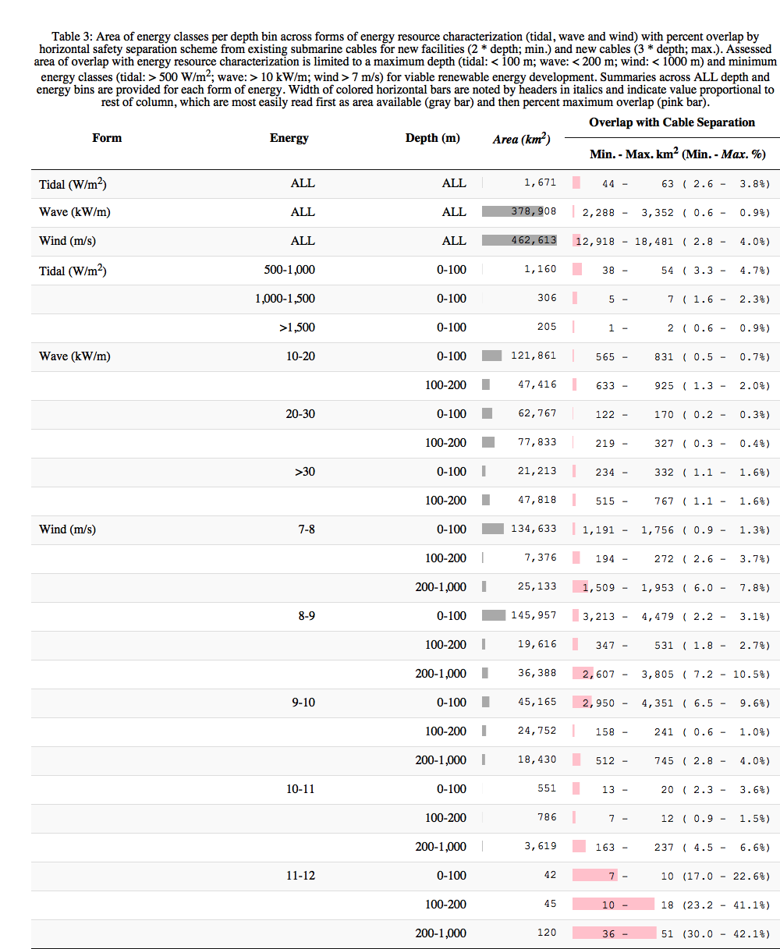

### Tidal

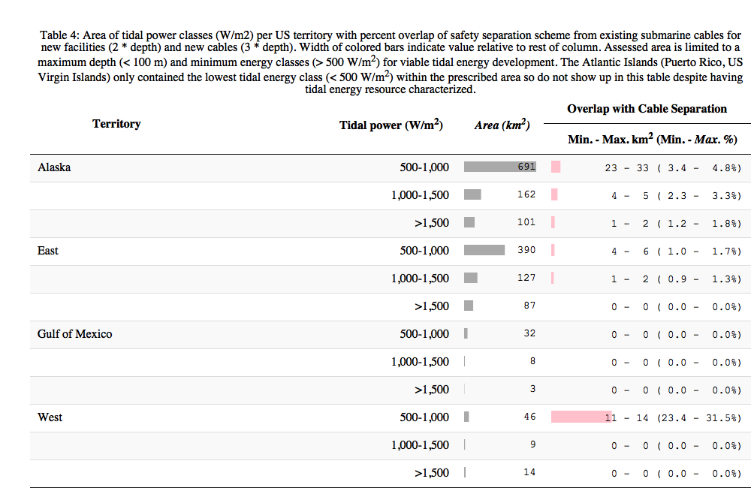

### Wave

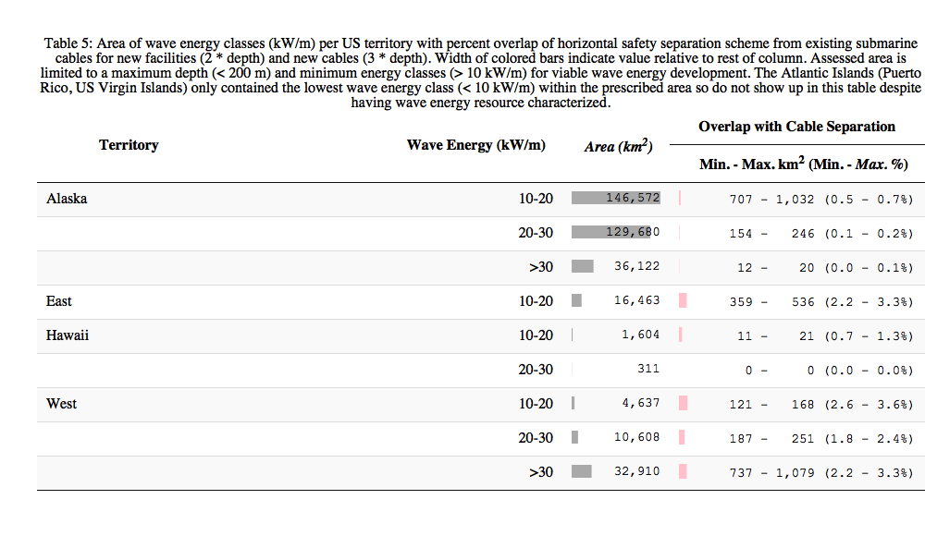

### Wind

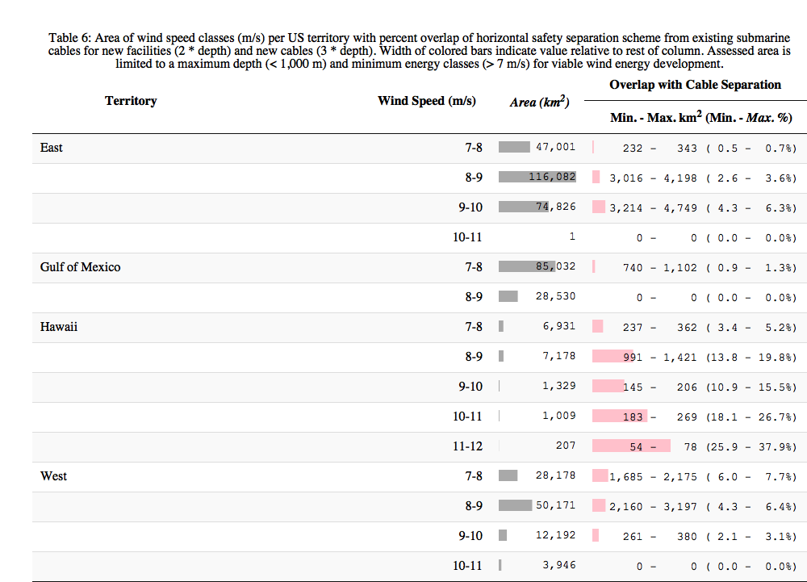

# Discussion

Besides the [Marine Cadastre](http://marinecadastre.gov) national marine spatial planning effort coordinated by NOAA and BOEM, other ocean regional planning efforts recognize submarine cables in their data catalogs: [Mid-Atlantic Regional Ocean Council (MARCO)](http://midatlanticocean.org) portal (New York, New Jersey, Delaware, Maryland and Virginia); [Northeast Regional Ocean Council (NROC)](http://northeastoceancouncil.org/) portal (Maine, New Hampshire, Vermont, Massachusetts, Rhode Island, and Connecticut); [Governors’ South Atlantic Alliance (GSAA)](http://southatlanticalliance.org/) portal (North Carolina, South Carolina, Georgia and Florida); [Gulf of Mexico Alliance](http://www.gulfofmexicoalliance.org/) portal (Florida, Alabama, Mississippi, Louisiana and Texas); and [West Coast Ocean Partnership](http://www.westcoastoceans.org/) (Washington, Oregon and California).

Although the US currently only has one marine renewable energy facility in full production at Block Island NJ, many more are in pilot and proposal phases[15] with much future potential (Beiter et al. 2017; Lehmann et al. 2017; Uihlein and Magagna 2016). The Virginia Wind Energy Area (WEA) offshore from Virginia Beach currently has five proposed/ongoing offshore wind related activites with some potential for conflict given three submarine cables ready for service in the near future, discoverable via [SubmarineCableMap.com](http://submarinecablemap.com): MAREA (Q1 2018), Midgardsormen (Q2 2019), BRUSA (Q2 2018). In New York the Interior Department auctioned nearly 80,000 acres offshore for commercial wind energy development in December, 2016. New Jersey has 2 renewable energy leases signed by BOEM as of February, 2016. In Massachusetts, BOEM approved the site assessment plan for a lease with Bay State Wind in June of 2017 and is in process with another offshore lease between Statoil Wind and PNE Wind with bids recieved in January, 2017. In Rhode Island, besides the existing Block Island wind facility in production, BOEM is reviewing a site assessment plan for the North Lease Area recieved from Deepwater Wind April of 2016. In Delaware on December of 2016 BOEM approved the assignemnt of an offshore wind lease to GSOE I. In Oregon, Oregon State University's Northwest National Marine Renewable Energy Center is in the permitting phase to develop the South Energy Test Site (SETS) facility for testing wave energy converters (WECs). In California, a competitive bidding process is underway between Trident Winds and Statoil Wind for an offshore area near Morro Bay. In Hawaii, BOEM is in the area identification stage of the leasing process for two call areas north and south of Oahu.

## Conclusion

Given climate change impacts of fossil fuel energy production (Pachauri et al. 2015), development of clean renewable energy alternatives are imperative for the sustainable future of the United States and rest of the planet. These energy sources however vary widely in geographic and temporal availability and may compete with other uses. The submarine cable industry provides critical power and telecommunication services, such that safe operation and maintenance must be heeded as marine renewable energy sources are developed (Communications Security, Reliability and Interoperability Council IV 2014, 2016). The submarine cable safety avoidance zones created and evaluated through this report are products intended to minimize conflict at the plannnig stage between these competing uses.

The proposed avoidance areas for submarine cables should be deemed advisory. Overlap with the new facility (3z) or cable (2z) buffers around existing submarine cables does not nullify the possibility of renewable energy development there. Rather, it should alert the developer to negotiate reasonable terms with the cable operator via contacting the cable industry, such as the North American Submarine Cable Association[16] or the International Cable Protection Committee[17]. These avoidance zones are advised according to traditional methods of submarine cable repair involving grappling of the submarine cable and buoying to the surface for repair, hence allowance for sway of boat as a function of depth. In future, use of more sophisticated remotely operated vehicles may narrow safe operating distances. These avoidance areas are limited to the most recent submarine cable data. Any planning for marine renewable energy should consult the latest electronic navigation charts and contact the cable industry for confirmation.

Overlap between existing submarine cables and viable marine renewable energy sources is generally minimal (maximum 3.8% for tidal, 0.9% for wave and 4.0% for wind; Table 3) meaning the two industries are generally compatible into the future. Specific high energy areas already noted, such as Puget Sound for tidal, Oregon for wave, and Oahu for wind, do exist and may inevitably conflict with future plans (eg planned cables and wind energy areas in Virginia Beach), however reasonable terms for operation and maintenance are negotiable. This new spatial seperation scheme from existing submarine cables serves to alert developers so such negotiations can be an early part of the planning process.

# (APPENDIX) Appendix

# Maps by US Territory of Cable Buffer and Renewable Energy

## Tide

### Alaska

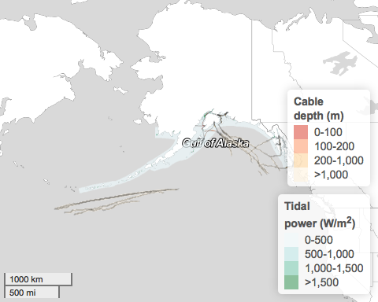

Figure 3 Map of tidal power () in Alaska with submarine cables (black lines) and advisory buffers colored by bottom depth. The buffers are plotted with transparency so the inner more opaque band represents the advised horizontal separation scheme for new facilities (2 * depth) and outer less opaque band the scheme for new cables (3 * depth). At large scales this detail is not visible. Alternatively, you can zoom and pan interactively on these layers at <http://ecoquants.github.io/nrel-cables/maps.html>.

### East

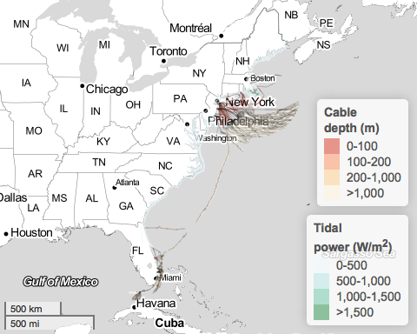

Figure 4 Map of tidal power () in the East with submarine cables (black lines) and advisory buffers colored by bottom depth. The buffers are plotted with transparency so the inner more opaque band represents the advised horizontal separation scheme for new facilities (2 * depth) and outer less opaque band the scheme for new cables (3 * depth). At large scales this detail is not visible. Alternatively, you can zoom and pan interactively on these layers at <http://ecoquants.github.io/nrel-cables/maps.html>.

### Gulf of Mexico

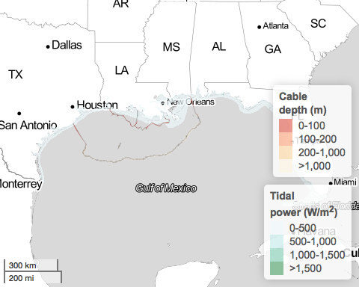

Figure 5 Map of tidal power () in the Gulf of Mexico with submarine cables (black lines) and advisory buffers colored by bottom depth. The buffers are plotted with transparency so the inner more opaque band represents the advised horizontal separation scheme for new facilities (2 * depth) and outer less opaque band the scheme for new cables (3 * depth). At large scales this detail is not visible. Alternatively, you can zoom and pan interactively on these layers at <http://ecoquants.github.io/nrel-cables/maps.html>.

### Puerto Rico

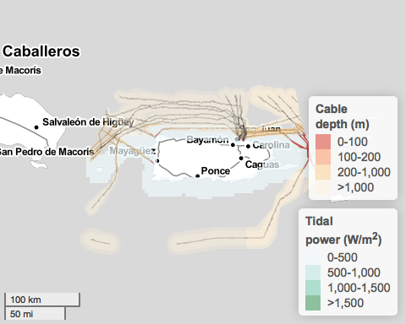

Figure 6 Map of tidal power () in Puerto Rico with submarine cables (black lines) and advisory buffers colored by bottom depth. The buffers are plotted with transparency so the inner more opaque band represents the advised horizontal separation scheme for new facilities (2 * depth) and outer less opaque band the scheme for new cables (3 * depth). At large scales this detail is not visible. Alternatively, you can zoom and pan interactively on these layers at <http://ecoquants.github.io/nrel-cables/maps.html>.

### US Virgin Islands

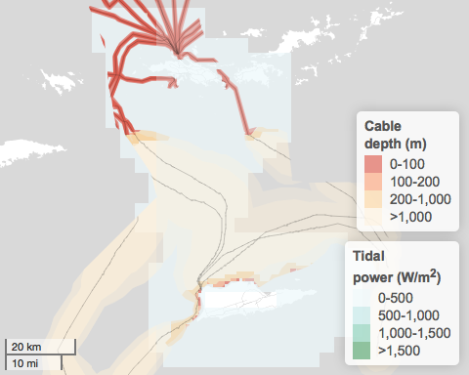

Figure 7 Map of tidal power () in the US Virgin Islands with submarine cables (black lines) and advisory buffers colored by bottom depth. The buffers are plotted with transparency so the inner more opaque band represents the advised horizontal separation scheme for new facilities (2 * depth) and outer less opaque band the scheme for new cables (3 * depth). At large scales this detail is not visible. Alternatively, you can zoom and pan interactively on these layers at <http://ecoquants.github.io/nrel-cables/maps.html>.

### West

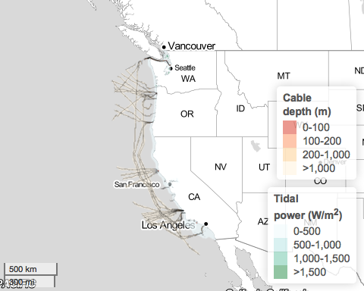

Figure 8 Map of tidal power () in the West with submarine cables (black lines) and advisory buffers colored by bottom depth. The buffers are plotted with transparency so the inner more opaque band represents the advised horizontal separation scheme for new facilities (2 * depth) and outer less opaque band the scheme for new cables (3 * depth). At large scales this detail is not visible. Alternatively, you can zoom and pan interactively on these layers at <http://ecoquants.github.io/nrel-cables/maps.html>.

## Wave

### Alaska

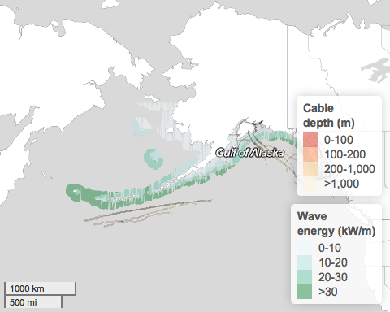

Figure 9 Map of wave energy () in Alaska with submarine cables (black lines) and advisory buffers colored by bottom depth. The buffers are plotted with transparency so the inner more opaque band represents the advised horizontal separation scheme for new facilities (2 * depth) and outer less opaque band the scheme for new cables (3 * depth). At large scales this detail is not visible. Alternatively, you can zoom and pan interactively on these layers at <http://ecoquants.github.io/nrel-cables/maps.html>.

### East

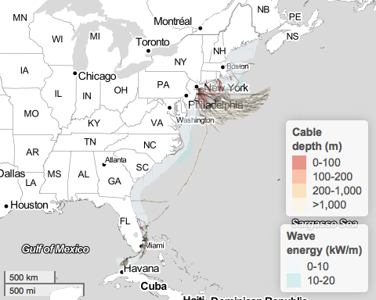

Figure 10 Map of wave energy () in the East with submarine cables (black lines) and advisory buffers colored by bottom depth. The buffers are plotted with transparency so the inner more opaque band represents the advised horizontal separation scheme for new facilities (2 * depth) and outer less opaque band the scheme for new cables (3 * depth). At large scales this detail is not visible. Alternatively, you can zoom and pan interactively on these layers at <http://ecoquants.github.io/nrel-cables/maps.html>.

### Gulf of Mexico

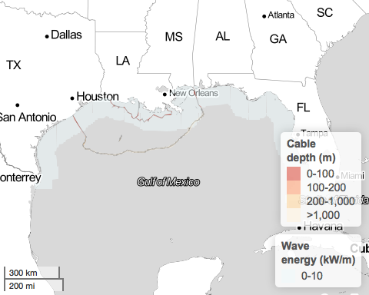

Figure 11 Map of wave energy () in the Gulf of Mexico with submarine cables (black lines) and advisory buffers colored by bottom depth. The buffers are plotted with transparency so the inner more opaque band represents the advised horizontal separation scheme for new facilities (2 * depth) and outer less opaque band the scheme for new cables (3 * depth). At large scales this detail is not visible. Alternatively, you can zoom and pan interactively on these layers at <http://ecoquants.github.io/nrel-cables/maps.html>.

### Hawaii

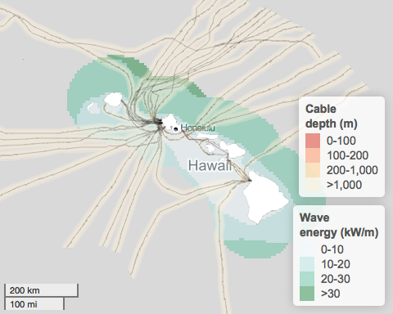

Figure 12 Map of wave energy () in Hawaii with submarine cables (black lines) and advisory buffers colored by bottom depth. The buffers are plotted with transparency so the inner more opaque band represents the advised horizontal separation scheme for new facilities (2 * depth) and outer less opaque band the scheme for new cables (3 * depth). At large scales this detail is not visible. Alternatively, you can zoom and pan interactively on these layers at <http://ecoquants.github.io/nrel-cables/maps.html>.

### Puerto Rico

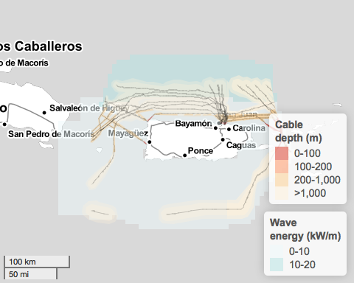

Figure 13 Map of wave energy () in Puerto Rico with submarine cables (black lines) and advisory buffers colored by bottom depth. The buffers are plotted with transparency so the inner more opaque band represents the advised horizontal separation scheme for new facilities (2 * depth) and outer less opaque band the scheme for new cables (3 * depth). At large scales this detail is not visible. Alternatively, you can zoom and pan interactively on these layers at <http://ecoquants.github.io/nrel-cables/maps.html>.

### US Virgin Islands

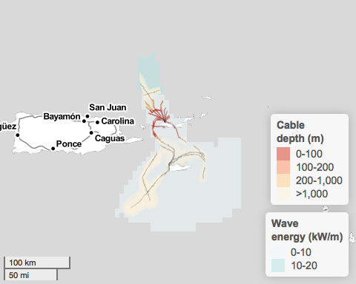

Figure 14 Map of wave energy () in the US Virgin Islands with submarine cables (black lines) and advisory buffers colored by bottom depth. The buffers are plotted with transparency so the inner more opaque band represents the advised horizontal separation scheme for new facilities (2 * depth) and outer less opaque band the scheme for new cables (3 * depth). At large scales this detail is not visible. Alternatively, you can zoom and pan interactively on these layers at <http://ecoquants.github.io/nrel-cables/maps.html>.

### West

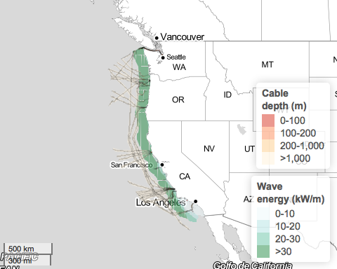

Figure 15 Map of wave energy () in the West with submarine cables (black lines) and advisory buffers colored by bottom depth. The buffers are plotted with transparency so the inner more opaque band represents the advised horizontal separation scheme for new facilities (2 * depth) and outer less opaque band the scheme for new cables (3 * depth). At large scales this detail is not visible. Alternatively, you can zoom and pan interactively on these layers at <http://ecoquants.github.io/nrel-cables/maps.html>.

## Wind

### East

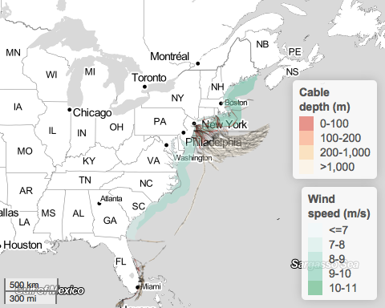

Figure 16 Map of wind speed () in the East with submarine cables (black lines) and advisory buffers colored by bottom depth. The buffers are plotted with transparency so the inner more opaque band represents the advised horizontal separation scheme for new facilities (2 * depth) and outer less opaque band the scheme for new cables (3 * depth). At large scales this detail is not visible. Alternatively, you can zoom and pan interactively on these layers at <http://ecoquants.github.io/nrel-cables/maps.html>.

### Gulf of Mexico

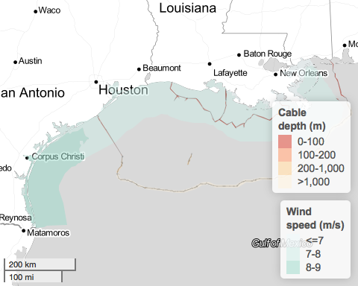

Figure 17 Map of wind speed () in the Gulf of Mexico with submarine cables (black lines) and advisory buffers colored by bottom depth. The buffers are plotted with transparency so the inner more opaque band represents the advised horizontal separation scheme for new facilities (2 * depth) and outer less opaque band the scheme for new cables (3 * depth). At large scales this detail is not visible. Alternatively, you can zoom and pan interactively on these layers at <http://ecoquants.github.io/nrel-cables/maps.html>.

### Hawaii

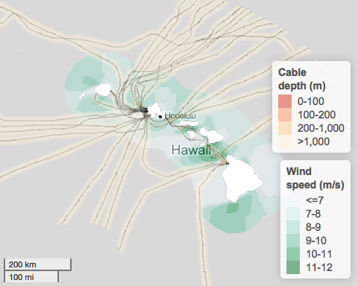

Figure 18 Map of wind speed () in Hawaii with submarine cables (black lines) and advisory buffers colored by bottom depth. The buffers are plotted with transparency so the inner more opaque band represents the advised horizontal separation scheme for new facilities (2 * depth) and outer less opaque band the scheme for new cables (3 * depth). At large scales this detail is not visible. Alternatively, you can zoom and pan interactively on these layers at <http://ecoquants.github.io/nrel-cables/maps.html>.

### West

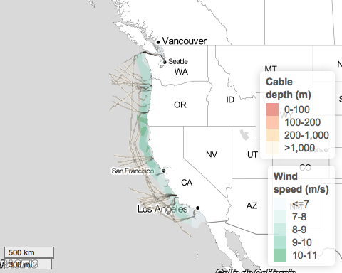

Figure 19 Map of wind speed () in the West with submarine cables (black lines) and advisory buffers colored by bottom depth. The buffers are plotted with transparency so the inner more opaque band represents the advised horizontal separation scheme for new facilities (2 * depth) and outer less opaque band the scheme for new cables (3 * depth). At large scales this detail is not visible. Alternatively, you can zoom and pan interactively on these layers at <http://ecoquants.github.io/nrel-cables/maps.html>.

# References

Beiter, P., Musial, W., Kilcher, L., Maness, M., & Smith, A. (2017). *An Assessment of the Economic Potential of Offshore Wind in the United States from 2015 to 2030*. NREL (National Renewable Energy Laboratory (NREL), Golden, CO (United States)). <https://tethys.pnnl.gov/sites/default/files/publications/Beiter-et-al-2017-NETL.pdf>

Communications Security, Reliability and Interoperability Council IV. (2014). *Protection of Submarine Cables Through Spatial Separation*. <http://transition.fcc.gov/pshs/advisory/csric4/CSRIC_IV_WG8_Report1_3Dec2014.pdf>

Communications Security, Reliability and Interoperability Council IV. (2016). *Clustering of Cables and Cable Landings*.

Flanders Marine Institute. (2016). Maritime Boundaries Geodatabase: Maritime Boundaries and Exclusive Economic Zones (200NM), version 9. <http://www.marineregions.org/>. Accessed 25 April 2017

Gilman, P., Maurer, B., Feinberg, L., Duerr, A., Peterson, L., Musial, W., et al. (2016). *National Offshore Wind Strategy: Facilitating the Development of the Offshore Wind Industry in the United States.* Office of Energy Efficiency; Renewable Energy (EERE), Washington, DC (United States). <https://www.boem.gov/National-Offshore-Wind-Strategy/>

Haas, K. A., Fritz, H. M., French, S. P., Smith, B. T., & Neary, V. (2011). *Assessment of energy production potential from tidal streams in the United States*. Georgia Tech Research Corporation, Atlanta, GA (United States). <https://www.osti.gov/scitech/servlets/purl/1219367>

Jacobson, P. T., Hagerman, G., & Scott, G. (2011). *Mapping and Assessment of the United States Ocean Wave Energy Resource*. <http://www.osti.gov/scitech/servlets/purl/1060943>

Lehmann, M., Karimpour, F., Goudey, C. A., Jacobson, P. T., & Alam, M.-R. (2017). Ocean wave energy in the United States: Current status and future perspectives. *Renewable and Sustainable Energy Reviews*, *74*, 1300–1313. doi:[10.1016/j.rser.2016.11.101](https://doi.org/10.1016/j.rser.2016.11.101)

Lowndes, J. S. S., Best, B. D., Scarborough, C., Afflerbach, J. C., Frazier, M. R., O’Hara, C. C., et al. (2017). Our path to better science in less time using open data science tools. *Nature Ecology & Evolution*, *1*(6), 160. doi:[10.1038/s41559-017-0160](https://doi.org/10.1038/s41559-017-0160)

Madeyski, L., & Kitchenham, B. (2015). Reproducible researchwhat, why and how. *Wroclaw University of Technology, PRE W*, *8*. <http://madeyski.e-informatyka.pl/download/MadeyskiKitchenham15.pdf>. Accessed 3 October 2017

Musial, W., Heimiller, D., Beiter, P., Scott, G., & Draxl, C. (2016). *2016 Offshore Wind Energy Resource Assessment for the United States*. NREL (National Renewable Energy Laboratory (NREL), Golden, CO (United States)). <http://www.nrel.gov/docs/fy16osti/66599.pdf>

Pachauri, R. K., Mayer, L., & Intergovernmental Panel on Climate Change (Eds.). (2015). *Climate change 2014: Synthesis report*. Geneva, Switzerland: Intergovernmental Panel on Climate Change.

Schwartz, M., Heimiller, D., Haymes, S., & Musial, W. (2010). *Assessment of offshore wind energy resources for the United States*. National Renewable Energy Laboratory (NREL), Golden, CO. <https://pdfs.semanticscholar.org/ee6a/c56b0ff8a7c56c575cf774001a9f27490907.pdf>

Uihlein, A., & Magagna, D. (2016). Wave and tidal current energy review of the current state of research beyond technology. *Renewable and Sustainable Energy Reviews*, *58*, 1070–1081. <http://www.sciencedirect.com/science/article/pii/S1364032115016676>

VLIZ. (2017). IHO Sea Areas, version 2. VLIZ. <http://www.marineregions.org/>. Accessed 2 July 2017

Weatherall, P., Marks, K. M., Jakobsson, M., Schmitt, T., Tani, S., Arndt, J. E., et al. (2015). A new digital bathymetric model of the world’s oceans. *Earth and Space Science*, *2*(8), 2015EA000107. doi:[10.1002/2015EA000107](https://doi.org/10.1002/2015EA000107)

1. NREL Wind Prospector: <https://maps.nrel.gov/wind-prospector/>
2. NREL MHK Atlas: <https://maps.nrel.gov/mhk-atlas>
3. North American Submarine Cable Association (NASCA): <https://www.n-a-s-c-a.org>
4. International Cable Protection Committee (ICPC): <https://www.iscpc.org>
5. MarineCadastre.gov cable metadata: <https://coast.noaa.gov/dataservices/Metadata/TransformMetadata?u=https://coast.noaa.gov/data/Documents/Metadata/harvest/MarineCadastre/NOAAChartedSubmarineCables.xml&f=html>
6. GEBCO_2014 Grid, version 20150318, www.gebco.net
7. NREL Wind Prospector: <https://maps.nrel.gov/wind-prospector/>
8. NREL MHK Atlas: <https://maps.nrel.gov/mhk-atlas>
9. Wind data for 90-meter offshore: <http://www.nrel.gov/gis/data_wind.html>
10. International Cable Protection Committee (ICPC): <https://www.iscpc.org>
11. North American Submarine Cable Association (NASCA): <https://www.n-a-s-c-a.org>
12. The "one-sixth rule" for Albers Equal Area Conic projection: <http://desktop.arcgis.com/en/arcmap/latest/map/projections/albers-equal-area-conic.htm#GUID-2158C4F9-F197-458E-94F0-84933C1BE6B7>
13. NREL Wind Prospector: <https://maps.nrel.gov/wind-prospector/>
14. NREL MHK Atlas: <https://maps.nrel.gov/mhk-atlas>
15. BOEM Renewable Energy Programs state activities: <https://www.boem.gov/Renewable-Energy-State-Activities/>
16. North American Submarine Cable Association (NASCA): <https://www.n-a-s-c-a.org>
17. International Cable Protection Committee (ICPC): <https://www.iscpc.org>